Project Design Phase-II Technology Stack (Architecture & Stack)

|  |  |
| --- | --- |
| Date | 03/10/2022 |
| Team ID | PNT2022TMID14299 |
| Project Name | Personal Assistance for Seniors Who Are Self- Reliant. |
| Maximum Marks | 4 Marks |

Technical Architecture:

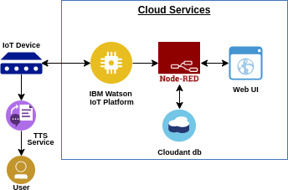

Table-1: Components & Technologies:

|  |  |  |  |
| --- | --- | --- | --- |
| **S. No** | **Component** | **Description** | **Technology** |
| 1. | User Interface | Mobile App | MIT |
| 2. | Application Logic-1 | Gathering medicine details and check the timings | Python |
| 3. | Application Logic-2 | alarms | IBM Watson |
| 4. | Cloud Database | Database Service on Cloud | IBM Cloudant DB |

Table-2: Application Characteristics:

|  |  |  |  |
| --- | --- | --- | --- |
| **S. No** | **Characteristics** | **Description** | **Technology** |
| 1. | Open-Source Frameworks | Mobile application development setup, programming the IoT device, text to speechservice,  storing details in cloud | MIT, IBM Watson, node red, IBM cloud |
| 2. | Security Implementations | Implementing encryption for security purpose | SHA-256. |
| 3. | Scalable Architecture | Application is able to load as many members aslogged in | MIT, IBM Watson |
| 4. | Availability | Application is available 24/7 | MIT, IBM Watson, node  red, IBM cloud |
| 5. | Performance | Reminder with correct timing | IBM Watson, IBM IoT Platform |